**Lab Manual- Create Sample DotNet Console App and Store in Github**

**Prepared for**:

**Date:** 18th Nov 2018

**Prepared by:** Aditi Shrivastava

Document Name: Lab Manual

**Document Number** SysOpsLab312

**Contributor:**

Table of Contents

1 OBJECTIVE 3

2 PRE-REQUISISTE 3

3 Create DotNet Core Console App 3

3.1 **Create your app** 3

3.2 **Build and Run Your App** 6

3.3 **Update Your App** 8

4 Push the Code to Source Code Repository (Github) 10

4.1 **Create a Repo in Github** 10

4.2 **Initialize Local Repo and Push the code to Github** 11

5 Update the Code and Push again to Repository (Github) 15

5.1 **Update Your App** 15

# OBJECTIVE

For various exercise we need to setup the local development environment where developer will create and update the code for application.

# PRE-REQUISISTE

* Accounts in Azure
* A local Computer with 4 CPU, 16 GB RAM, 200 GB disk space

# Create DotNet Core Console App



## **Create your app**

A simple application written in C# that prints Hello, World! to the consol

* In your command prompt, run the following command to create your app:

**dotnet new console -o myApp**

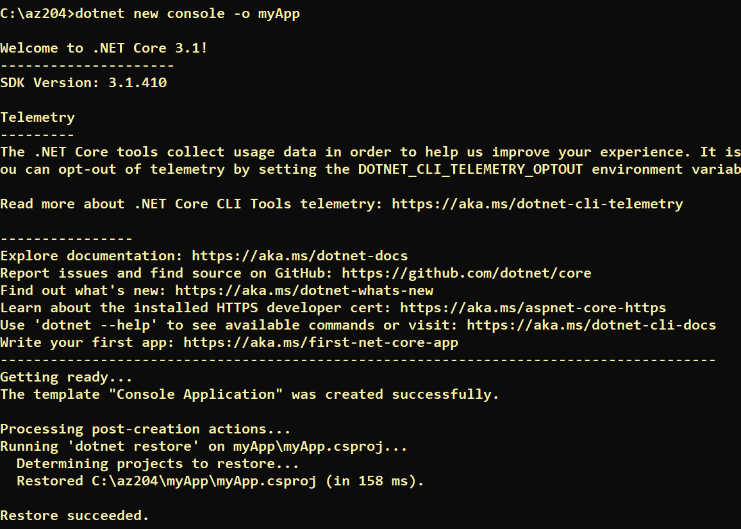

**[Note ] What do these commands mean?**

**The dotnet new console** command creates a new console app for you. The **-o parameter** creates a directory named **myApp**where your app is stored and populates it with the required files.

* Then, navigate to the new directory created by the previous command:

cd myApp

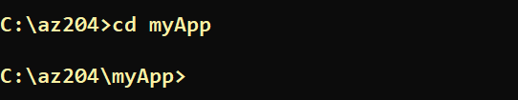

* Now open **Code .** to Launc VS Code Editor

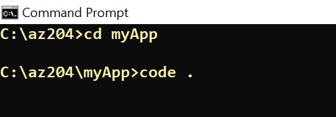

* It Open the project in VS Code Editor

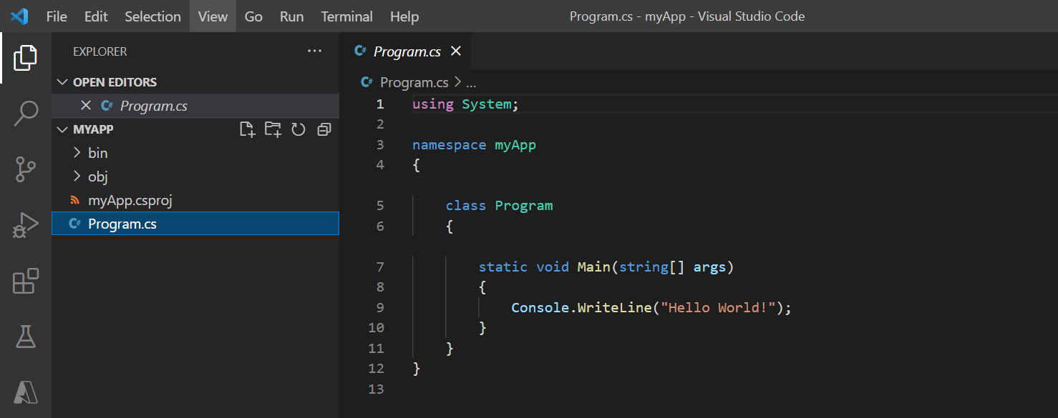

* When You create project it also install dependecies

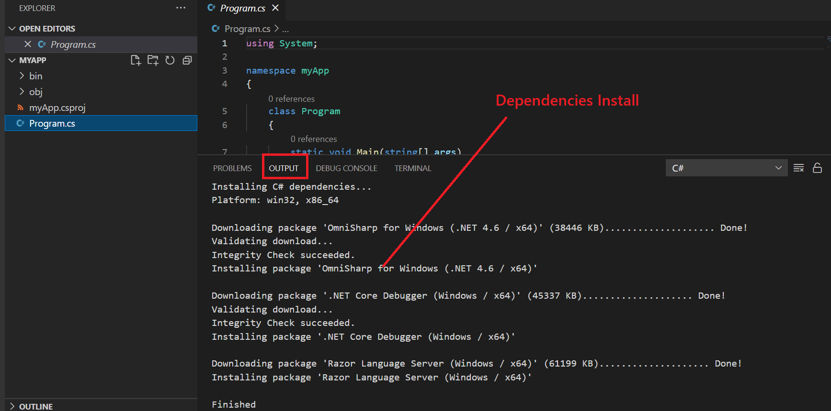

* You Can also see the projectd details

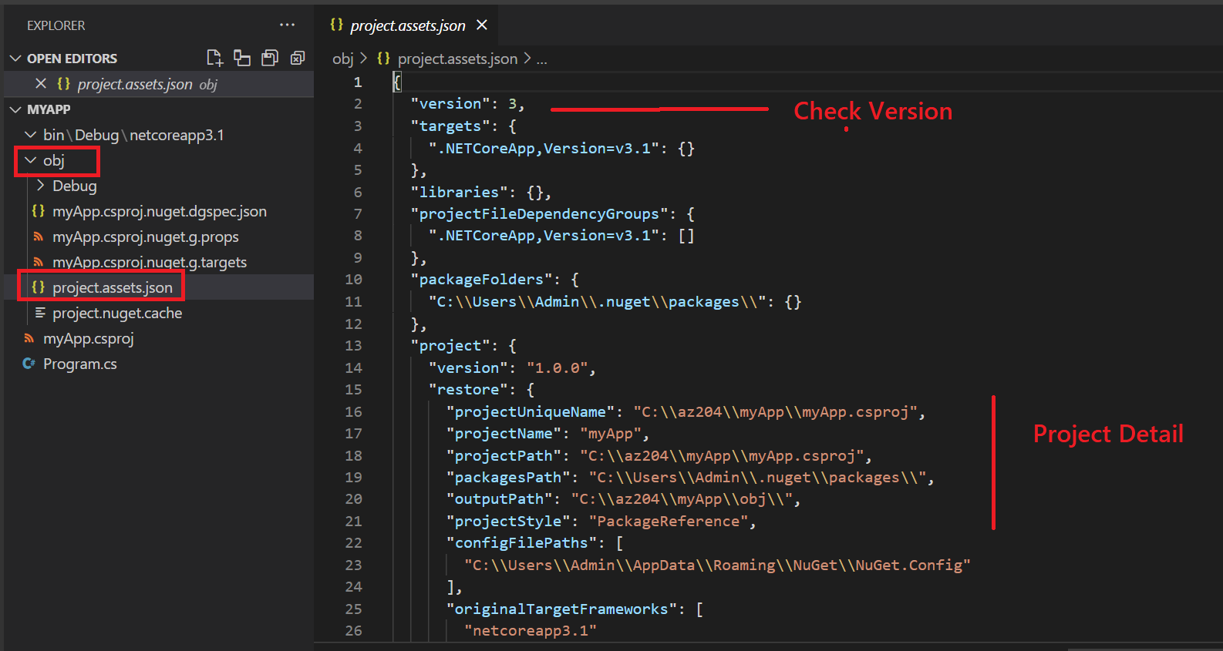

* The main file in the**myApp** folder is **Program.cs**. By default, it already contains the necessary code to write "**Hello World!"** to the Console.

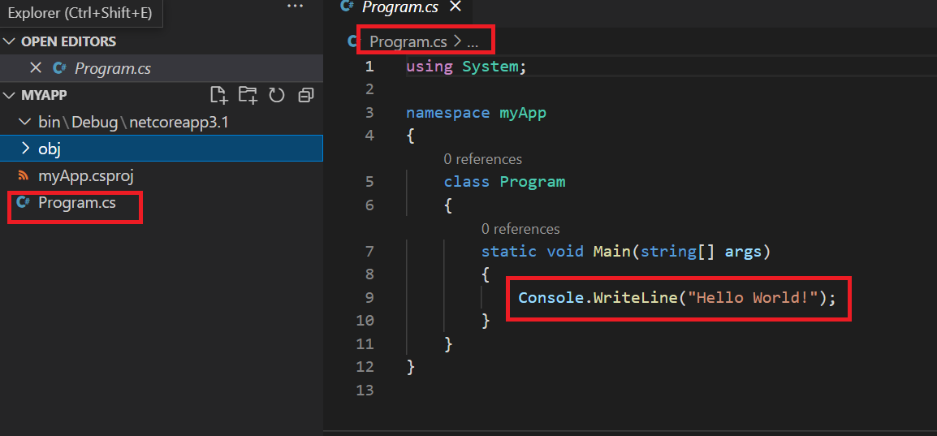

## **Build and Run Your App**

* Now we are going to Build the program (Build compiles the source code into a (hopefully) runnable application)

Dotnet Build

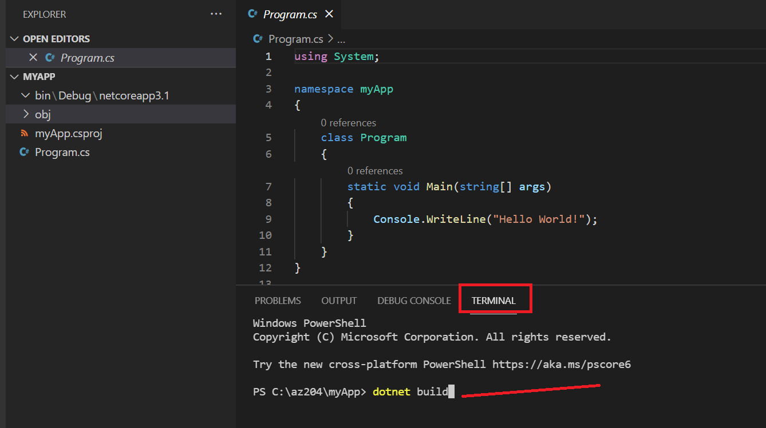

* When you Build the program compiles the source code into a (hopefully) runnable application) . You can check the output from bin directory and Notice **myapp.exe /Myapp.dll**

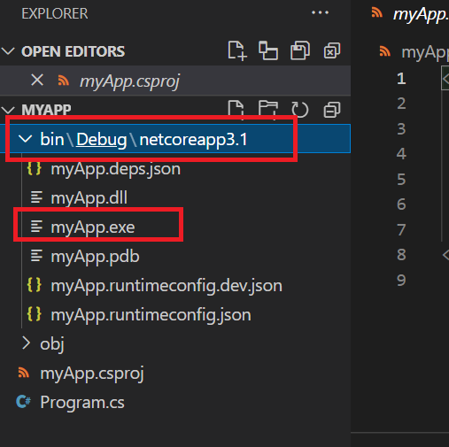

* In your command prompt, run the following command:

Dotnet Run

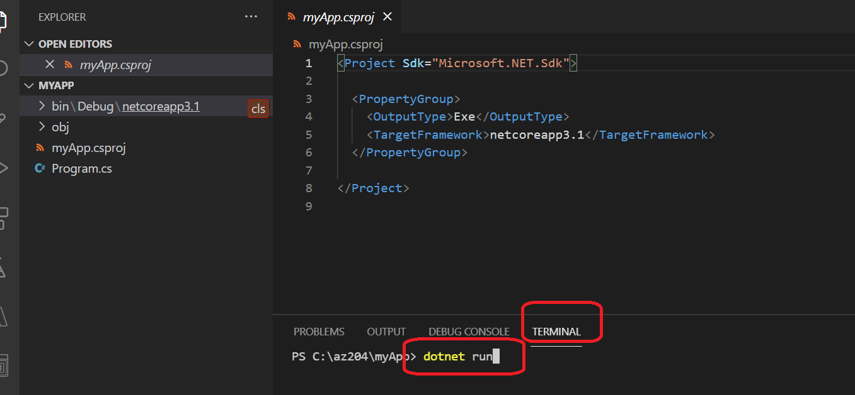

* Congratulations, you've built and run your first .NET app!

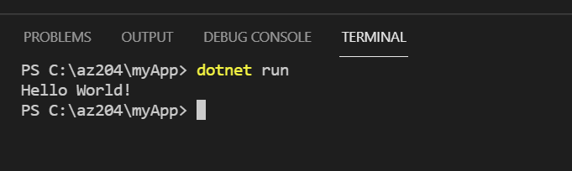

## **Update Your App**

Now lets make small changes in code. For that we go to Program.cs and add some line in Println statement

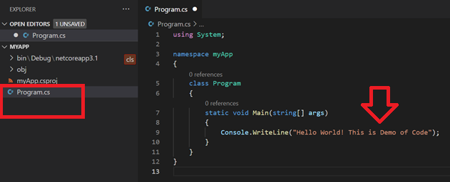

Now save **– File 🡪 Save All**

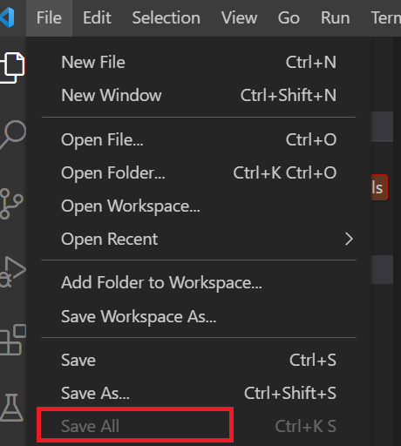

Now again Build and Run the Code.

**DotNet Build**

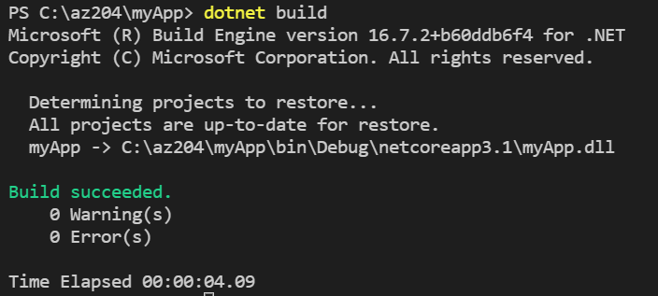

**DotNet Run**

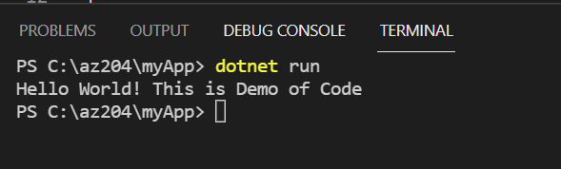

# Push the Code to Source Code Repository (Github)



## **Create a Repo in Github**

* Goto Github and click New Repo
* Type the Reponame as „myapp“
* Type some description
* Without clicking the any other check box

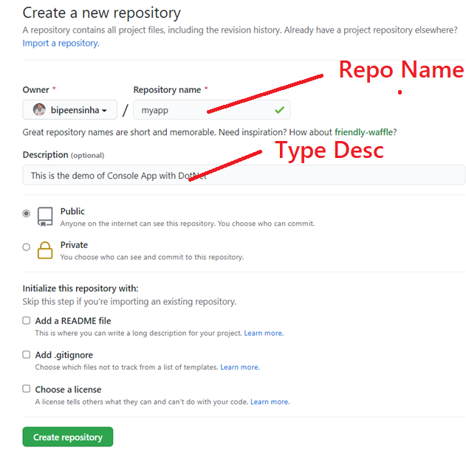

* Click **Create Repository**

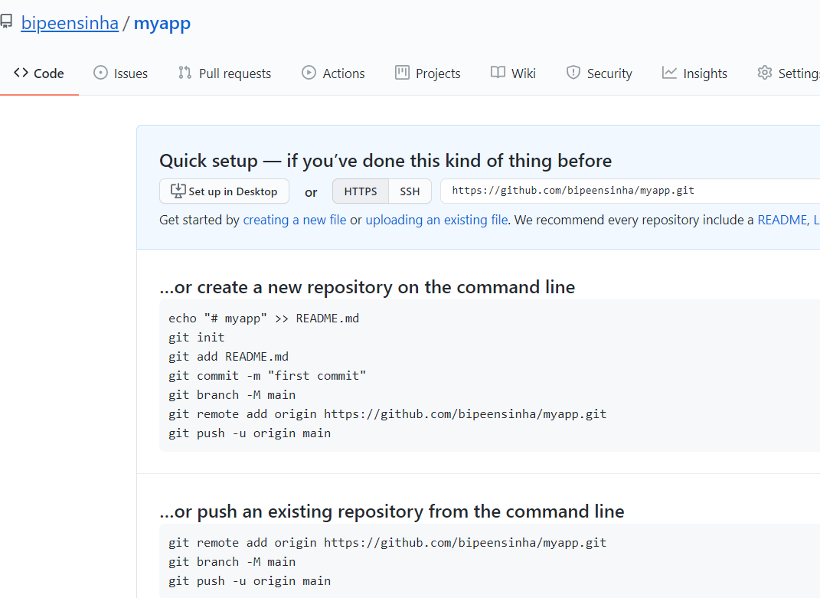

## **Initialize Local Repo and Push the code to Github**

* On the local VS Code terminal type below command

**Git Init**

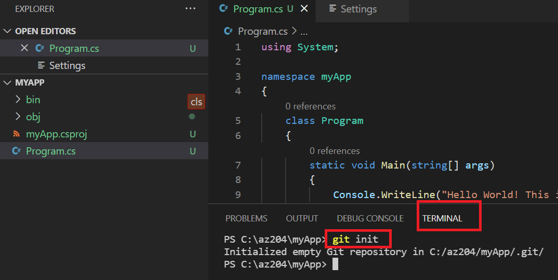

* Now add the code to git Quue with git add . ( where . (dot) represent everything in current directory)

**Git add .**

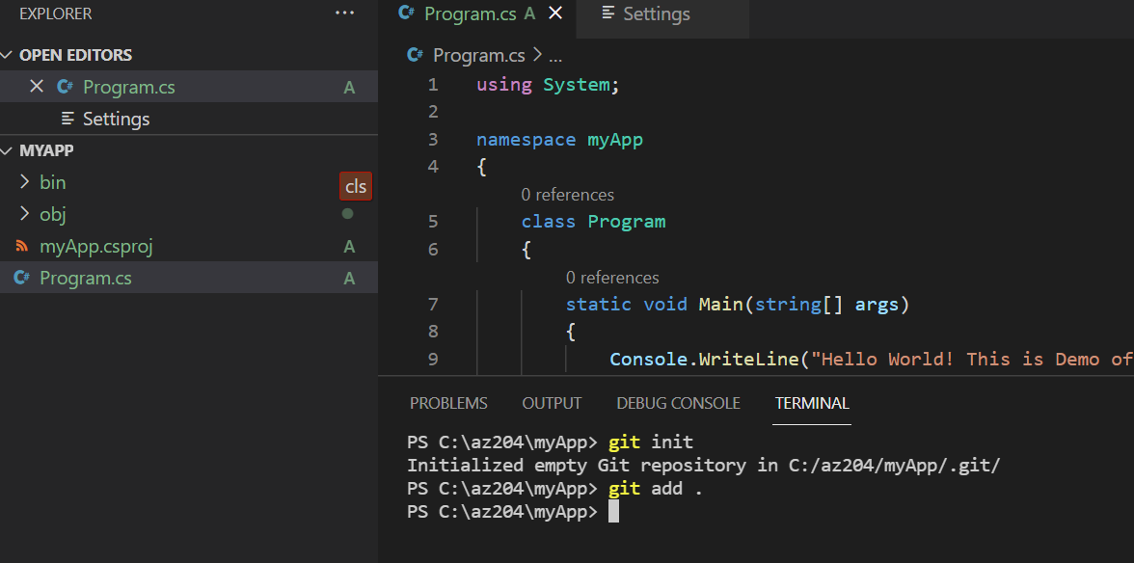

* Now copy the git remote orgin command from github and past it here. It is going to tel your git agent installed your laptop that which repo to push the code

**git remote add origin https://github.com/bipeensinha/myapp.git**

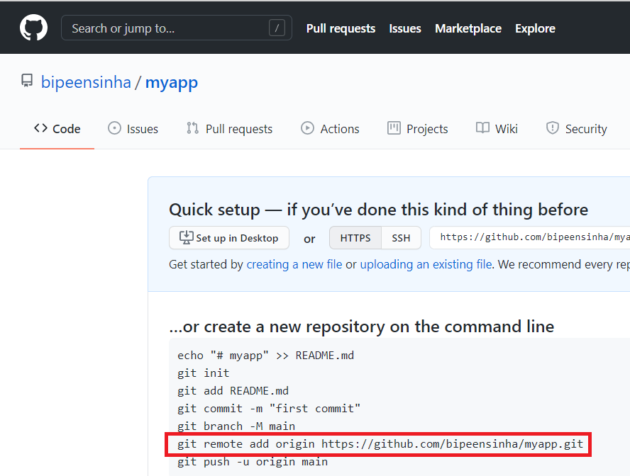

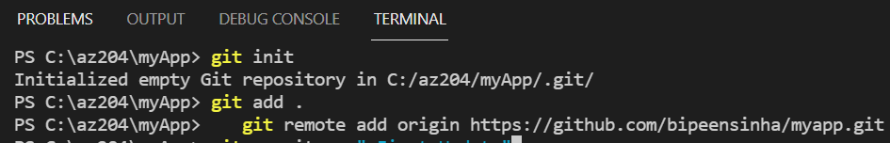

* Now commit the code to Github queue

**git commit -m "first commit"**

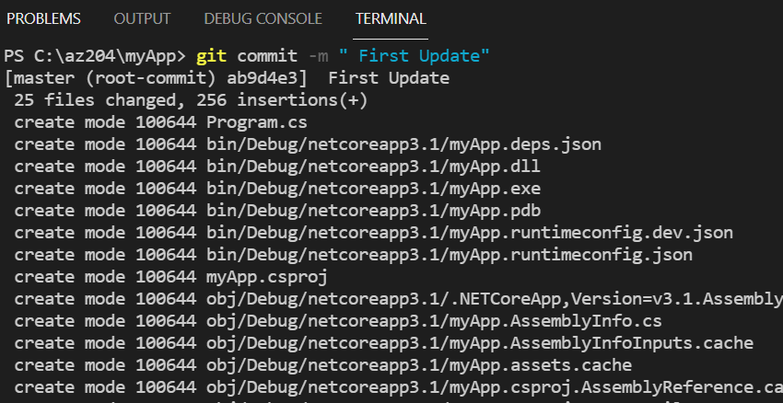

* Now Push the code to Github Repository

**git push –all**

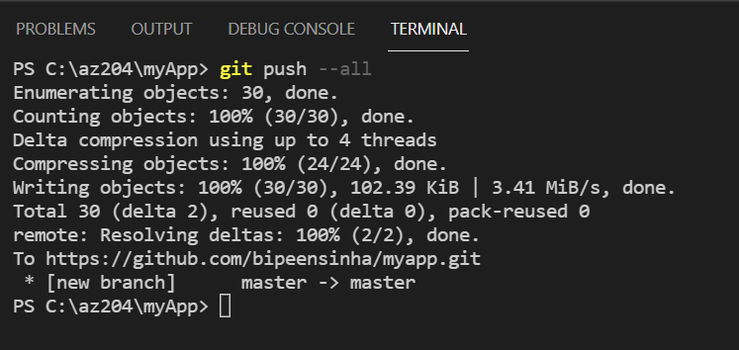

* Now go to github Portal , Refresh it and check you have your code there.

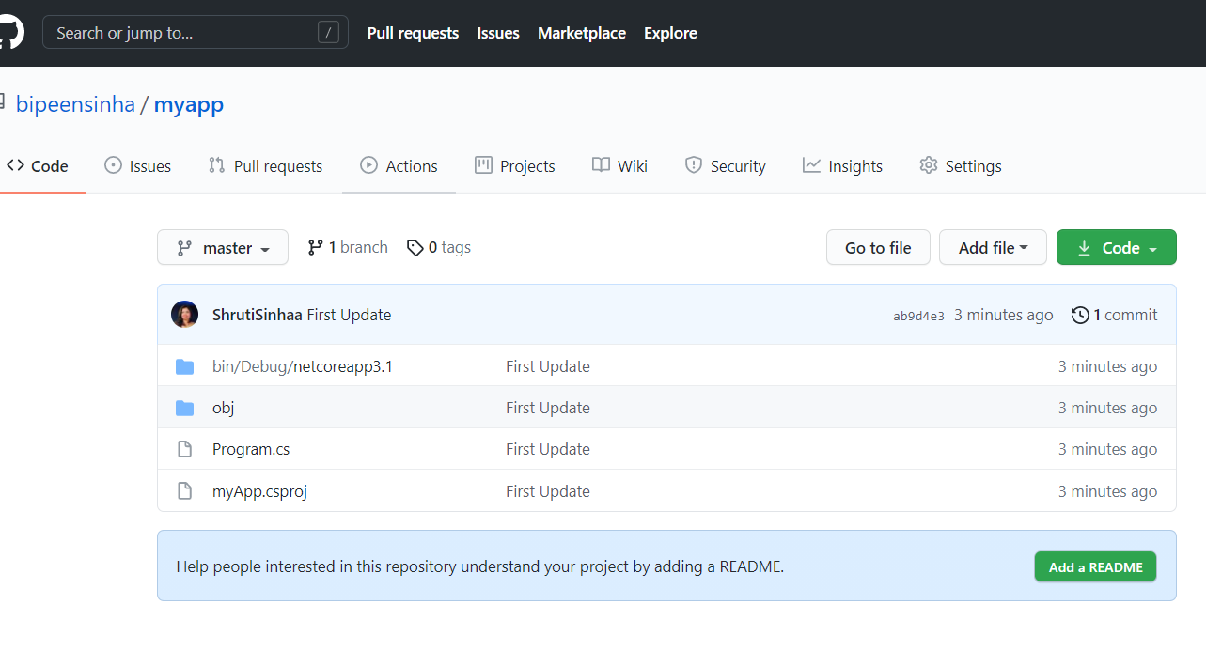

# Update the Code and Push again to Repository (Github)

## **Update Your App**

Now lets make small changes in code. For that we go to Program.cs and add some line in **Println statement**

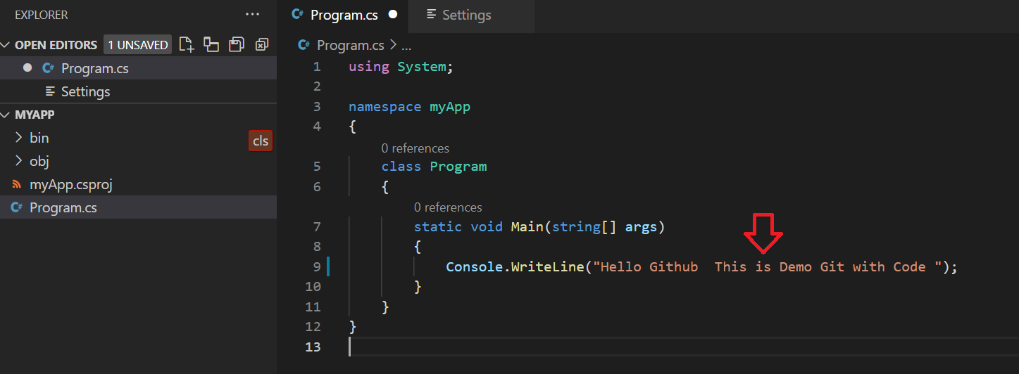

Now save **– File 🡪 Save All**



Now again Build Code.

**DotNet Build**



* Now add the code to git Quue with git add . ( where . (dot) represent everything in current directory)

**Git add .**

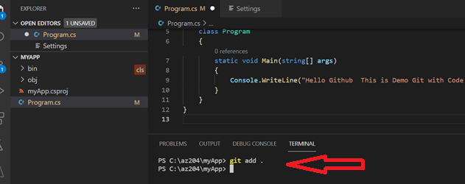

* Now commit the code to Github queue

**git commit -m "Second commit"**

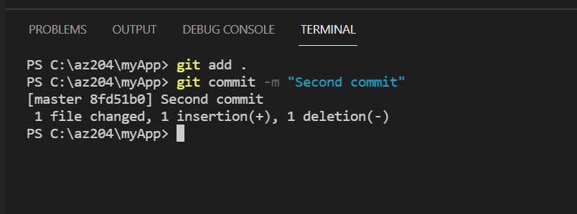

* Now Push the code to Github Repository

**Git push --all**

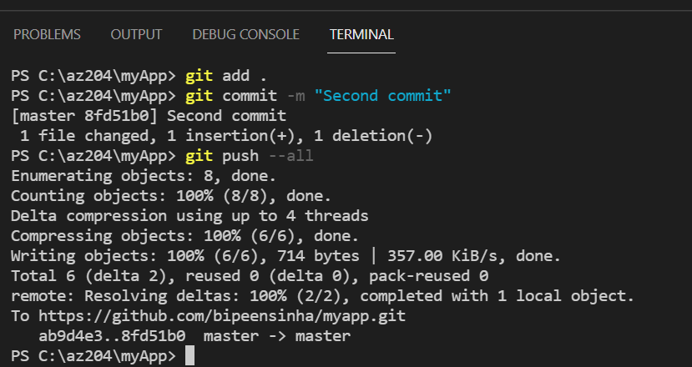

* Now go to github Portal, Refresh it and check you have your code there.

